Week 4
Session 16
Task 4.1
package com.example.College;
import org.springframework.web.bind.annotation.GetMapping;
import org.springframework.web.bind.annotation.RestController;
@RestController
public class HelloController {
@GetMapping("/")
public String home() {
return "Spring Boot Servlet Application is Running!";
}
}

Session 17
Task 4.2
package service;
import org.springframework.stereotype.Service;
@Service
public class HelloService {
public String getMessage() {
return "Hello from Service Layer!";
}
public String getCourse() {
return "Spring Boot Dependency Injection Example";
}
}

Output:
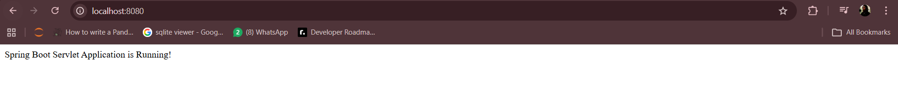
Task 4.3
Interface
package com.example.College.service;
public interface PaymentService {
String processPayment();
}

Implementation Class
package service;
import org.springframework.stereotype.Service;
@Service
public class PaymentServiceImpl implements PaymentService {
@Override
public String processPayment() {
return "Payment processed successfully!";
}
}

Session 18
Task 4.4
EmailNotificationService.java
package com.example.College;
import org.springframework.stereotype.Service;
@Service("emailService")
public class EmailNotificationService implements NotificationService {
@Override
public String sendNotification() {
return "Email Notification Sent!";
}

package com.example.College;

import org.springframework.beans.factory.annotation.Autowired;
import org.springframework.beans.factory.annotation.Qualifier;
import org.springframework.web.bind.annotation.GetMapping;
import org.springframework.web.bind.annotation.RestController;

NotificationController.java
@RestController
public class NotificationController {
@Autowired
@Qualifier("emailService")
private NotificationService notificationService;
@GetMapping("/notify")
public String sendNotification() {
return notificationService.sendNotification();
}
}
NotificationService.java

package com.example.College;
public interface NotificationService {
String sendNotification();
}

SMSNotificationService.Java
package com.example.College;
import org.springframework.stereotype.Service;
@Service("smsService")
public class SMSNotificationService implements NotificationService {
@Override
public String sendNotification() {
return "SMS Notification Sent!";
}
}

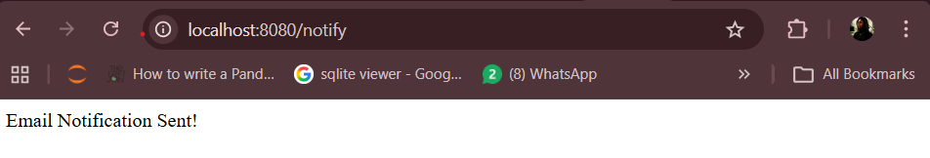

Task 4.5
OptionalService.java
package com.example.College;
import org.springframework.stereotype.Component;
@Component
public class OptionalService {
public String getMessage() {
return "Optional Service is available!";
}
}

OptionalController.java
package com.example.College;
import org.springframework.beans.factory.annotation.Autowired;
import org.springframework.web.bind.annotation.GetMapping;
import org.springframework.web.bind.annotation.RestController;
@RestController
public class OptionalController {
@Autowired(required = false)
private OptionalService optionalService;
@GetMapping("/optional")
public String checkOptionalService() {
if (optionalService != null) {
return optionalService.getMessage();
} else {
return "Optional Service is NOT available!";
}
}
}
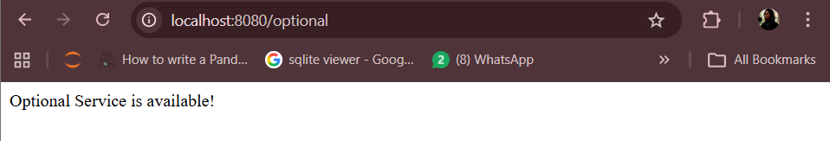

Session 19
Task 4.6
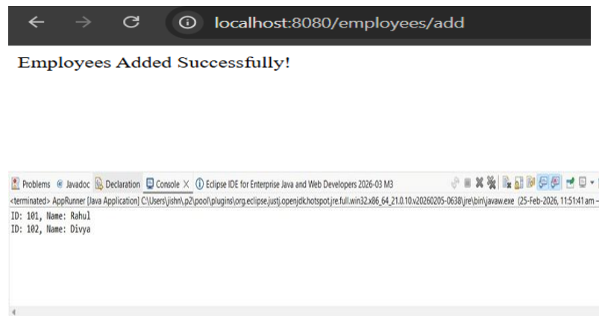
AppRunner.java:
package com.company.core.config;
import org.springframework.context.annotation.AnnotationConfigApplicationContext;
import com.company.core.service.StaffService;
public class AppRunner {
public static void main(String[] args) {
AnnotationConfigApplicationContext context =
new AnnotationConfigApplicationContext("com.company.core");
StaffService service = context.getBean(StaffService.class);
service.registerStaff(101, "Rahul");
service.registerStaff(102, "Divya");
service.displayStaff();
context.close();
}
}

StaffService.java:
package com.company.core.service;
import org.springframework.beans.factory.annotation.Autowired;
import org.springframework.stereotype.Component;
import com.company.core.model.Staff;
import com.company.core.repo.StaffRepository;
@Component
public class StaffService {
@Autowired
private StaffRepository repository;
public void registerStaff(int id, String name) {
Staff staff = new Staff(id, name);
repository.addStaff(staff);
}
public void displayStaff() {
repository.getAllStaff().forEach(System.out::println);
}
}

StaffRepository.java:
package com.company.core.repo;
import java.util.ArrayList;
import java.util.List;
import org.springframework.stereotype.Component;
import com.company.core.model.Staff;
@Component
public class StaffRepository {
private List<Staff> staffList = new ArrayList<>();
public void addStaff(Staff staff) {
staffList.add(staff);
}
public List<Staff> getAllStaff() {
return staffList;
}
}

Staff.java:
package com.company.core.model;
public class Staff {
private int id;
private String name;
public Staff(int id, String name) {
this.id = id;
this.name = name;
}
@Override
public String toString() {
return "ID: " + id + ", Name: " + name;
}
}

SESSION – 20
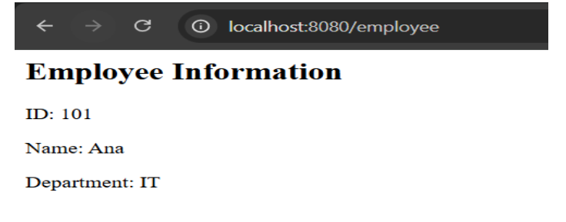
employee.jsp:
<%@ page contentType="text/html;charset=UTF-8" %>
<html>
<head>
<title>Employee Details</title>
</head>
<body>
<h2>Employee Information</h2>
<p>ID: ${employee.id}</p>
<p>Name: ${employee.name}</p>
<p>Department: ${employee.department}</p>
</body>
</html>

application.properties :
spring.mvc.view.prefix=/WEB-INF/jsp/
spring.mvc.view.suffix=.jsp

pom.xml:
<!-- JSP Engine -->
<dependency>
<groupId>org.apache.tomcat.embed</groupId>
<artifactId>tomcat-embed-jasper</artifactId>
</dependency>
<!-- JSTL -->
<dependency>
<groupId>jakarta.servlet.jsp.jstl</groupId>
<artifactId>jakarta.servlet.jsp.jstl-api</artifactId>
</dependency>

EmployeeMVCController.java:
package com.example.springboot;
import org.springframework.stereotype.Controller;
import org.springframework.ui.Model;
import org.springframework.web.bind.annotation.GetMapping;
@Controller
public class EmployeeMVCController {
@GetMapping("/employee")
public String showEmployee(Model model) {
Employee emp = new Employee(101, "Ana", "IT");
model.addAttribute("employee", emp);
return "employee"; // JSP file name
}
}

Employee.java:
package com.example.springboot;
public class Employee {
private int id;
private String name;
private String department;
public Employee(int id, String name, String department) {
this.id = id;
this.name = name;
this.department = department;
}
public int getId() { return id; }
public String getName() { return name; }
public String getDepartment() { return department; }
}

employee.jsp:
<%@ page contentType="text/html;charset=UTF-8" %>
<html>
<head>
<title>Employee Details</title>
</head>
<body>
<h2>Employee Information</h2>
<p>ID: ${employee.id}</p>
<p>Name: ${employee.name}</p>
<p>Department: ${employee.department}</p>
</body>
</html>

